**Project Description**

Coursera

**Project Description: -** This Scene is of a Football Ground which is near my House. The Scene Contains Asset Imported from asset store of the unity.

I have also added some simple animation which can observed after clicking the **play button** in the Unity.

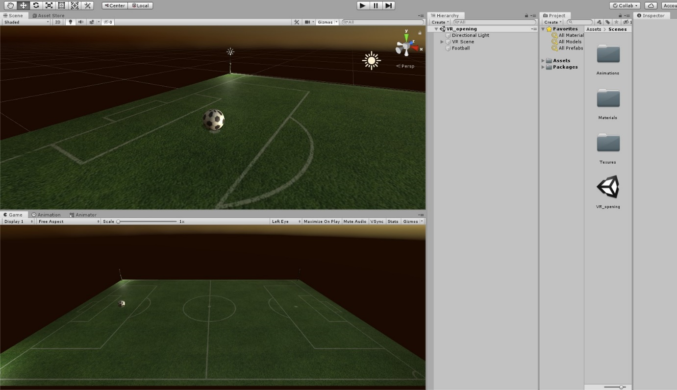

**Part A: - Descriptions of each element of the Project: -**

1. **Animations:-**  I have tried to incorporate some animations in objects like:-
2. **Football:-**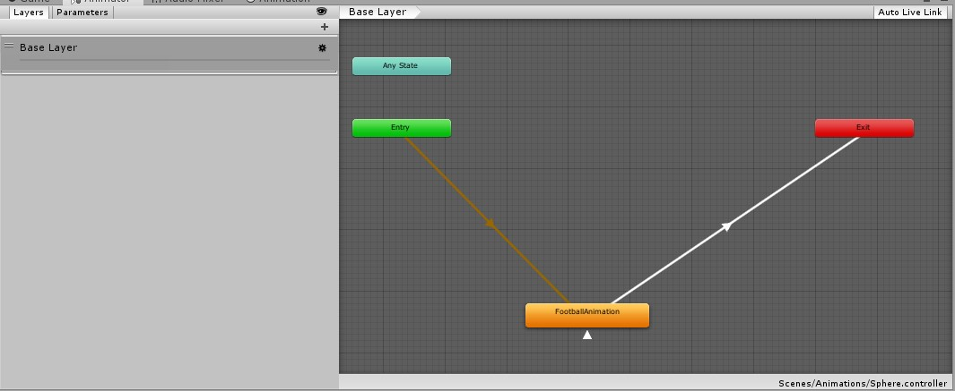

This is screenshot of the Animation, that was created in Unity. It basically changes the **translation** and **rotation** of the Football in during the gameplay. (not too fancy :D)

1. **Audio Animations: -**

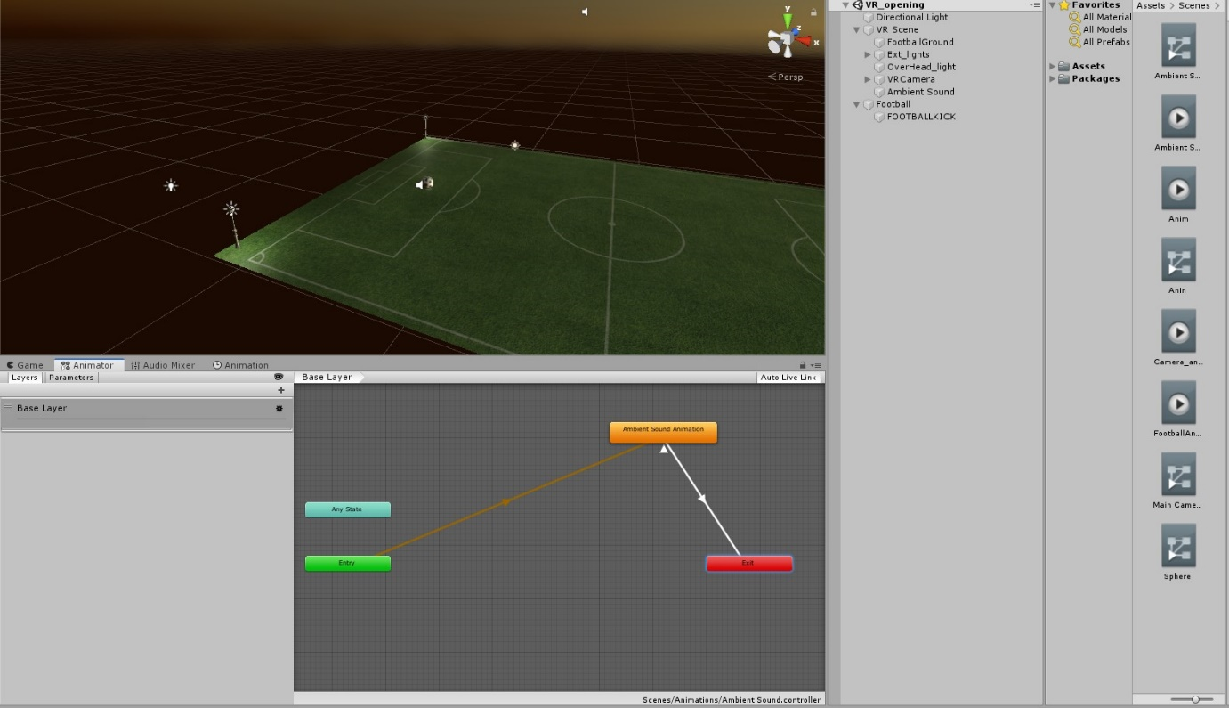

This is a basic animation that changes the pitch of the audio, during gameplay. The audio **is spatial(3D)** so, the changing of

the pitch is due to the change in **Rotations** and **translation** of audio.

(Used Adobe Audition for spatial audio conversion).

1. **Audio: -**

The audio was taken from the internet and is free for copyright. (link of website is at the end).

Using Audio mixer in Unity, I have adjusted the settings so, that both the audio (ambient and football kick) is audible during the **animations**

(P.S: - I am not expert in audio creation. So, don’t mind the quality of audio mixing :P)

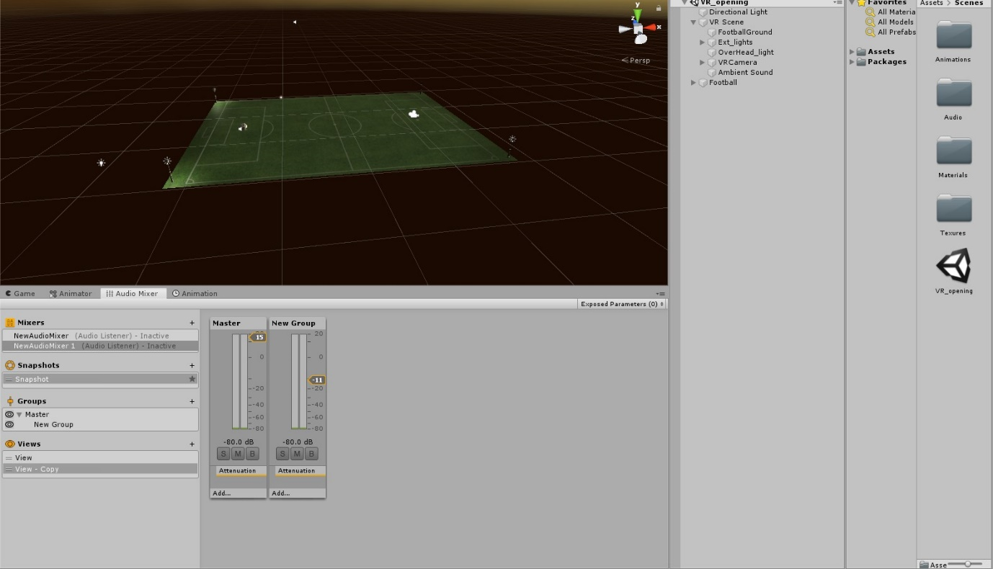

1. **Lighting: -**

For the lighting models, I have imported the assets from the unity asset store. The lights were placed inside the lamps so that there is no **halo around it.** 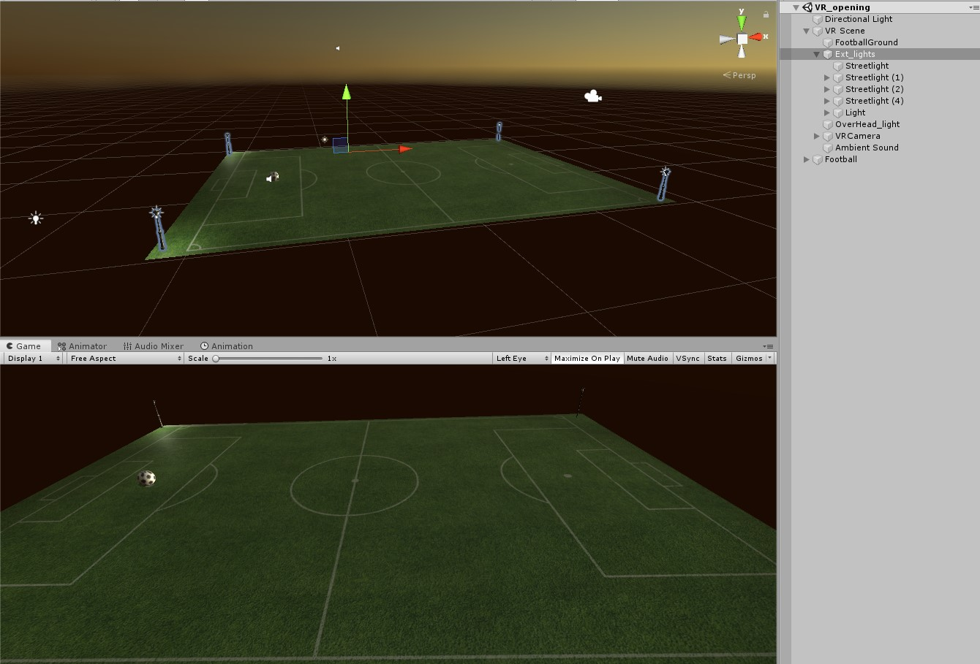

**Note: -** I have added an additional **point light** at the top of the scene for correct ambience (Named: - Overhead light).

**Part B: - Restrictions and Links of the assets: -**

1. **Restrictions: -**
2. The Version of Unity used for creating Scene is **2019.2.8f1. Download the same version** of the Unity to ensure there are no errors while playing the scene.
3. The VR SDK used is **Google Cardboard**, thus if you don’t have the same SDK installed in the UNITY, This Scene may not work.
4. The Scene should work on all the Modern hardware(android). If you don’t have VR supported (AR core) on your Android device, please consider using Unity instead.
5. I have Enclosed the Project Scene Files in zip format. Please ensure you **UNZIP it fully**, so that there is no importing Errors.

**2. Links: -**

Ambient sound audio:- <https://www.zapsplat.com/sound-effect-category/playgrounds/>

Football Kick Effect: -

<https://www.freesoundeffects.com/free-sounds/football-10104/>

Lightings models: -

<https://assetstore.unity.com/packages/3d/props/exterior/street-lights-pack-31644>

**This is Final Scene view that you should observe, while using UNTY play button.**

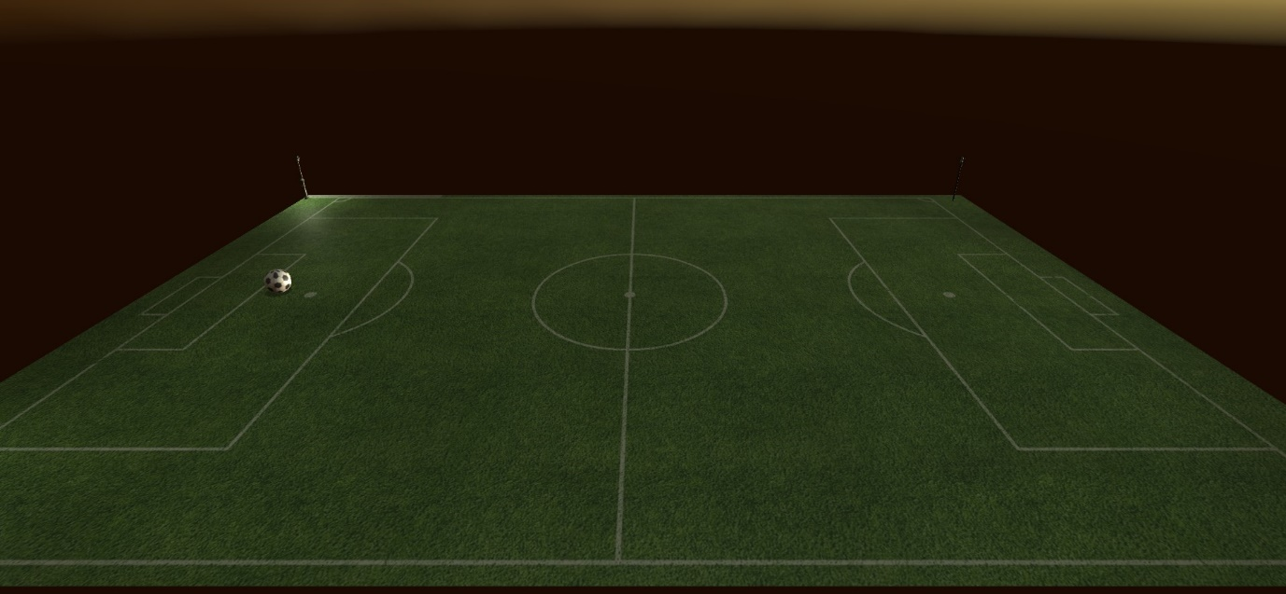

**P.S. If you have any doubts please feel free to comment by mentioning my name xD.**